DSC-3/BCAS/T/103: Database Management System

Total Credits: 02 Total Contact Hours: 30 Hrs
Maximum Marks: 50

Learning Objectives of the Course:

- Understand basic database management System
- Understand basic database management operations.
- Design E-R Model for given requirements

Course Outcomes (COs):

After completion of the course, students will be able to -
- Understand the basic concepts of database
- Understand the applications of database management system
- Create database tables in MySQL

Module No. | Topics / actual contents of the syllabus | Contact Hours
I | Introduction to Basic Concepts of DBMS: Introduction: Database, Database System application. Purpose of database system, Advantages & Disadvantages of DBMS, Schemas, Instances & Database state, Data independence, database system utilities, Database Architecture-Three level architecture | 10 Hrs
II | Database users & Administers responsibilities, Structure of DBMS: Types of Data model–Relational, E-R, Object based, Overview of Hierarchical & Network Data models, Phases of database design, E-R Model-Entity, Entity sets, Entity Types, Attribute, Attribute, types, Naming Conventions, Pictorial representation of ER (symbols) | 10 Hrs
III | Data Association: Data Association–Attribute association & Mapping Cardinalities, Constraints (Key  constraints, Integrity constraints, referential integrity, unique constraint, Null/Not Null constraint, Domain, Check constraint, Mapping constraints), DBMS Versus RDBMS | 10 Hrs

Textbooks:
- Database System Concepts-Korth, Silberschatz, Fifth Edition
- An Introduction to Database System–Bipin Desai, Revised Edition

Reference Books:

Database System Concepts-Navathe, Fourth Edition)

MySQL (TM): The Complete Reference - The Complete Reference, Vaswani Vikram

Database Users and User Interfaces
There are four different types of database-system users, differentiated by the way they expect to interact with the system. Different types of user interfaces have been designed for the different types of users.
Naive Users:-
➢ The Naïve Users are unsophisticated users who interact with the system by invoking one of the application programs that have been written previously. They need not be aware about the application program they only use it. For example, a bank teller who needs to transfer $50 from account A to account B invokes a program called transfer. This program asks the teller for the amount of money to be transferred, the account from which the money is to be transferred, and the account to which the money is to be transferred.
As another example, consider a user who wishes to find her account balance over the World Wide Web. Such a user may access a form, where she enters her account number. An application program at the Web server then retrieves the account balance, using the given account number, and passes this information back to the user. The typical user interface for naive users is a forms interface, where the user can fill in appropriate fields of the form. Naive users may also simply read reports generated from the database.
Application Programmer:- Application programmers are computer professionals who write application programs. Application programmers can choose from many tools to develop user interfaces. Rapid application development (RAD) tools are tools that enable an application programmer to construct forms and reports without writing a program. There are also special types of programming languages that combine imperative control structures (for example, for loops, while loops and if-then-else statements) with statements of the data manipulation language. These languages, sometimes called fourth-generation languages, often include special features to facilitate the generation of forms and the display of data on the screen. Most major commercial database systems include a fourth generation language.The application programs could be written in a general purpose programming language such as PASCAL, COBOL, C, C++.
Sophisticated User:- Sophisticated users interact with the system without writing programs. Instead, they form their requests in a database query language. They submit each such query to a query processor, whose function is to break down DML statements into instructions that the storage manager understands. Analysts who submit queries to explore data in the database fall in this category.
Specialized User:- Users who are responsible to write specialized database applications that do not fit into the conventional data processing system. For ex. Computer Aided Design (CAD), Artificial Intelligence System etc.

Database Administrator (DBA):
This is the chief administrator, who oversees and manages the database system (including the data and software). Duties include authorizing users to access the database, coordinating/monitoring its use, acquiring hardware/software for upgrades, etc. In large organizations, the DBA might have a support staff.
ROLE OF A DBA
Defining the Schema: The DBA defines the schema which contains the structure of the data in the application. The DBA determines what data needs to be present in the system how this data has to be represented and organized.
Defining Security & Integrity Checks: The DBA finds about the access restrictions to be defined and defines security checks accordingly. Data Integrity checks are also defined by the DBA.
Defining Backup / Recovery Procedures: The DBA also defines procedures for backup and recovery. Defining backup procedures includes specifying what data is to backed up, the periodicity of taking backups and also the medium and storage place for the backup data.
Monitoring Performance: The DBA has to continuously monitor the performance of the queries and take measures to optimize all the queries in the application.

DATA DICTIONARY
• The relational database system needs to maintain data about relation. This information is called data dictionary.
• In other word, a data dictionary is a set of metadata (i.e. data about data) which contains the definition and representation of data elements.
• The data dictionary is created when database is created.
• Then after, whenever the database is in operation data dictionary is updated automatically by DBMS. • The data dictionary is a reference for all database users.
The contents of dictionary are:
¬ Names of relations, time of its creation and when it was last accessed.
¬ The names and data types of its attributes of each relation.
¬ Domains of the attributes.
¬ Where the data is stored.
¬ Names of views defined on the database and definitions of those views.
¬ Constraints applied to tables.
¬ Names of authorized user and the rights and privileges they have granted.

Data models
Data models are the collection of conceptual tools which describes data, their relationship, their schematic and consistency constraints. In other word we can say that a database model defines the logical data structure & the data relationships. A Database model defines the logical design and structure of a database and defines how data will be stored, accessed and updated in a database management system.
Relational model in DBMS
In relational model, the data and relationships are represented by collection of inter-related tables. Each table is a group of column and rows, where column represents attribute of an entity and rows represents records. The table name and column names are helpful to interpret the meaning of values in each row. In the formal relational model terminology, a row is called a tuple, a column header is called an attribute, and the table is called a relation. The data type describing the types of values that can appear in each column is represented by a domain of possible values.
Relational Model (RM) represents the database as a collection of relations. A relation is nothing but a table of values. Every row in the table represents a collection of related data values. These rows in the table denote a real-world entity or relationship. The table name and column names are helpful to interpret the meaning of values in each row. The data are represented as a set of relations. In the relational model, data are stored as tables. However, the physical storage of the data is independent of the way the data are logically organized.
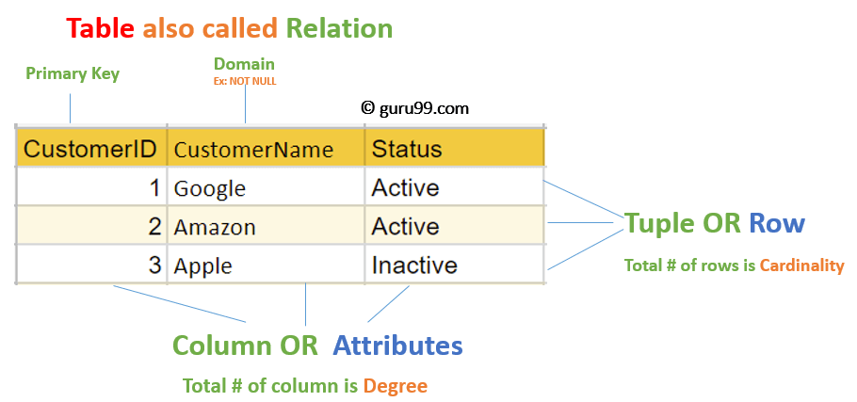

Relational Model Concepts in DBMS
1. Attribute: Each column in a Table. Attributes are the properties which define a relation. e.g., Student_Rollno, Name, etc.
2. Tables – In the Relational model the, relations are saved in the table format. It is stored along with its entities. A table has two properties rows and columns. Rows represent records and columns represent attributes.
3. Tuple – It is nothing but a single row of a table, which contains a single record.
4. Relation Schema: A relation schema represents the name of the relation with its attributes.
5. Degree: The total number of attributes which in the relation is called the degree of the relation.
6. Cardinality: Total number of rows present in the Table.
7. Column: The column represents the set of values for a specific attribute.
8. Relation instance – Relation instance is a finite set of tuples in the RDBMS system. Relation instances never have duplicate tuples.
9. Relation key – Every row has one, two or multiple attributes, which is called relation key.
10. Attribute domain – Every attribute has some pre-defined value and scope which is known as attribute domain.

Advantages of Relational Database Model
• Simplicity: A Relational data model in DBMS is simpler than the hierarchical and network model.
• Structural Independence: The relational database is only concerned with data and not with a structure. This can improve the performance of the model.
• Easy to use: The Relational model in DBMS is easy as tables consisting of rows and columns are quite natural and simple to understand
• Query capability: It makes possible for a high-level query language like SQL to avoid complex database navigation.
• Data independence: The Structure of Relational database can be changed without having to change any application.
• Scalable: Regarding a number of records, or rows, and the number of fields, a database should been larged to enhance its usability.
Disadvantages of Relational Model
• Few relational databases have limits on field lengths which can’t be exceeded.
• Relational databases can sometimes become complex as the amount of data grows, and the relations between pieces of data become more complicated.
• Complex relational database systems may lead to isolated databases where the information cannot be shared from one system to another
What is Network Model?
This model was formalized by the Database Task group in the 1960s. This model is the generalization of the hierarchical model. This model can consist of multiple parent segments and these segments are grouped as levels but there exists a logical association between the segments belonging to any level. Mostly, there exists a many-to-many logical association between any of the two segments. We called graphs the logical associations between the segments. Therefore, this model replaces the hierarchical tree with a graph-like structure, and with that, there can more general connections among different nodes. It can have M: N relations i.e, many-to-many which allows a record to have more than one parent segment. Here, a relationship is called a set, and each set is made up of at least 2 types of record which are given below:
- An owner record that is the same as of parent in the hierarchical model.
- A member record that is the same as of child in the hierarchical model.
Structure of a Network Model
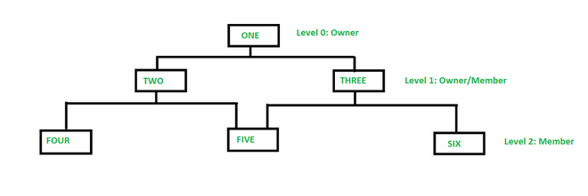
A Network data model
In the above figure, member TWO has only one owner ‘ONE’ whereas member FIVE has two owners i.e, TWO and THREE. Here, each link between the two record types represents 1 : M relationship between them. This model consists of both lateral and top-down connections between the nodes. Therefore, it allows 1: 1, 1 : M, M : N relationships among the given entities which helps in avoiding data redundancy problems as it supports multiple paths to the same record. There are various examples such as TOTAL by Cincom Systems Inc., EDMS by Xerox Corp., etc.
Example : Network model for a Finance Department.Below we have designed the network model for a Finance Department:
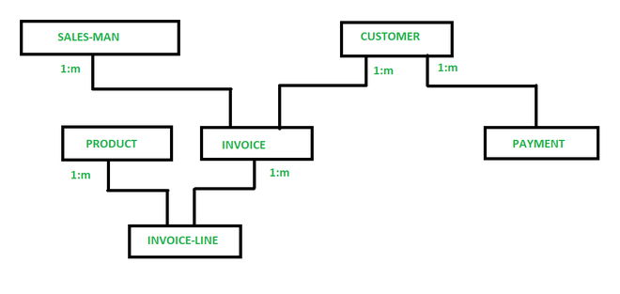
Network model of Finance Department.

So, in a network model, a one-to-many (1: N) relationship has a link between two record types. Now, in the above figure, SALES-MAN, CUSTOMER, PRODUCT, INVOICE, PAYMENT, INVOICE-LINE are the types of records for the sales of a company. Now, as you can see in the given figure, INVOICE-LINE is owned by PRODUCT & INVOICE. INVOICE has also two owners SALES-MAN & CUSTOMER.
Advantages of Network Model
- This model is very simple and easy to design like the hierarchical data model.
- This model is capable of handling multiple types of relationships which can help in modelling real-life applications, for example, 1: 1, 1: M, M: N relationships.
- In this model, we can access the data easily, and also there is a chance that the application can access the owner’s and the member’s records within a set.
- This network does not allow a member to exist without an owner which leads to the concept of Data integrity.
- Like a hierarchical model, this model also does not have any database standard,
- This model allows to represent multi parent relationships.
Disadvantages of Network Model
- The schema or the structure of this database is very complex in nature as all the records are maintained by the use of pointers.
- There’s an existence of operational anomalies as there is a use of pointers for navigation which further leads to complex implementation.
- The design or the structure of this model is not user-friendly.
- This model does not have any scope of automated query optimization.
- This model fails in achieving structural independence even though the network database model is capable of achieving data independence.
Features of Network Model in DBMS
- Data Relationship Representation: The network model uses a graph structure to represent data relationships. It allows many-to-many relationships, providing greater flexibility in how data is connected.
- Records and Sets: Data in a network model is organized into records and sets. Records are similar to rows in a relational table, and sets are used to define relationships between records, akin to links in a graph.
- Owner-Member Relationships: The network model defines data relationships using owner-member pairs. An owner record can be linked to multiple member records, and a member record can belong to multiple owner records, facilitating complex relationships.
- Navigational Access: The network model supports navigational data access, where records are accessed through predefined paths. This is different from relational models, which use declarative query languages like SQL.
- Hierarchical and Non-Hierarchical Structures: The network model can represent both hierarchical (tree-like) and non-hierarchical (graph-like) structures, providing flexibility in data modeling.
Operations on Network Model in DBMS
- Insertion: Adding new records and establishing owner-member relationships.
- Deletion: Removing records and maintaining data integrity by handling related records and relationships.
- Update: Modifying existing records and relationships between records.
- Traversal: Navigating through the network structure to access related records using predefined paths.
- Search: Retrieving specific records based on criteria by navigating the network structure.

Hierarchical data model
A hierarchical data model is a way to organize data into a hierarchy that looks like a family tree. There is a parent record, called a “root node,” with multiple “child nodes” connecting to it through links. There is only one parent node for each child node (although the parent node can have multiple children).

Example of a hierarchical data model
A good example of a hierarchical data model would be a directory. For example:
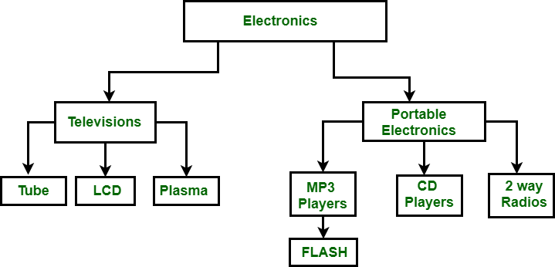
In this example, the root node is Electronics, which has two subcategories, or “child nodes”—Televisions and Portable Electronics. These categories or also a parent category to their own child nodes—for instance, under Television we see Tube, LCD, and Plasma. However, all the directories (records) fall under one single parent, the root node.
It’s most appropriate to use a hierarchical data model for data that’s already arranged in a parent-child pattern, with a single root point spanning out into multiple branches. For example, think of an org chart with multiple individual employees reporting to a single manager. Most of us have seen an example of a hierarchical data model in action—the Windows Registry in the Microsoft Windows operating system is a hierarchical database.
Advantages of a hierarchical model
The hierarchical data model has been popular since its inception, and it’s simple to see why:
- Easy to understand and use: The hierarchical data model mirrors the way we organize information in our minds. This makes it a natural fit for many applications, such as databases, file systems, and document management systems.
- Offers improved performance: When data is stored in a hierarchical structure, users can access related information with a single operation, which is much more efficient than retrieving data from separate tables.
- Easy to maintain: Maintaining this type of model is simple because all of the data is stored in a single table, so you don’t need to keep track of multiple tables to keep the data consistent across the entire system.
- Simplifies complex information: The hierarchical data model breaks down complex information into smaller, more manageable pieces. This makes it easier to work with large amounts of data.
- Supports multiple views of data: This model supports multiple views of data, which is important for applications that need to provide different users with alternate views of the same information. For example, a database system could allow managers to see employee data in a hierarchical structure, while employees could see the same data in a flat structure. This flexibility is not possible with other data models.
Disadvantages of a hierarchical model
- Limited flexibility: A hierarchical data model is fairly rigid, since the data is organized in a strict tree structure. If you want to add or remove data, you may need to rework the entire structure. This can also make it hard to query, since you need to follow the path through the hierarchy to find the desired information.
- Data redundancy: In a hierarchical data model, child nodes often contain duplicate copies of the data stored in their parent nodes. This can lead to wasted storage space and inconsistency in the data.
- Difference Between the Network Model and the Hierarchical Model

Feature | Hierarchical Model | Network Model
Structure | Tree-like structure | Graph structure
Relationships | One-to-many (single parent, multiple children) | Many-to-many (multiple parents and children)
Flexibility | Less flexible | More flexible
Data Access | Single access path | Multiple access paths
Redundancy | Higher redundancy due to rigid hierarchy | Lower redundancy due to shared relationships
Complexity | Simpler to design and implement | More complex to design and manage
Usage Scenario | Suitable for simple, hierarchical data structures | Suitable for complex, interconnected data structures
Efficiency | Efficient for hierarchical traversal | Efficient for complex queries and data retrieval
Example | Organizational chart | Telecommunications network

- Object Oriented Data Model :
In Object Oriented Data Model, data and their relationships are contained in a single structure which is referred as object in this data model. In this, real world problems are represented as objects with different attributes. All objects have multiple relationships between them. Basically, it is combination of Object Oriented programming and Relational Database Model as it is clear from the following figure :
- Object Oriented Data Model
- = Combination of Object Oriented Programming + Relational database model

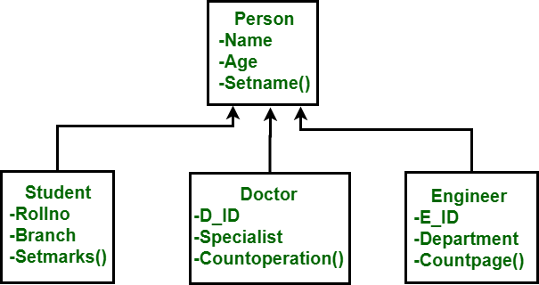
- Components of Object Oriented Data Model :
- Objects –
An object is an abstraction of a real world entity or we can say it is an instance of class. Objects encapsulates data and code into a single unit which provide data abstraction by hiding the implementation details from the user. For example: Instances of student, doctor, engineer in above figure.
- Attribute –
An attribute describes the properties of object. For example: Object is STUDENT and its attribute are Roll no, Branch, Setmarks() in the Student class.
- Methods –
Method represents the behavior of an object. Basically, it represents the real-world action. For example: Finding a STUDENT marks in above figure as Setmarks().
- Class –
A class is a collection of similar objects with shared structure i.e. attributes and behavior i.e. methods. An object is an instance of class. For example: Person, Student, Doctor, Engineer in above figure.
Advantages of Object Oriented Data Model :
- Codes can be reused due to inheritance.
- Easily understandable.
- Cost of maintenance can reduced due to reusability of attributes and functions because of inheritance.
Disadvantages of Object Oriented Data Model :
- It is not properly developed so not accepted by users easily.

Entity–relationship model (ER model)
An Entity–relationship model (ER model) describes the structure of a database with the help of a diagram An ER diagram shows the relationship among entity sets. An entity set is a group of similar entities and these entities can have attributes. In terms of DBMS, an entity is a table or attribute of a table in database, so by showing relationship among tables and their attributes, ER diagram shows the complete logical structure of a database.
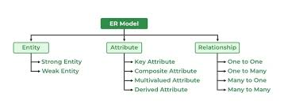

As shown in the above diagram, an ER diagram has three main components:
1. Entity
2. Attribute
3. Relationship
Entity: An entity is an object of concern to represent the things in real world and is distinguishable from other by certain property.e.g. car, table, book etc
Entity Set/Entity Type:
A collection of a similar kind of entities is called an entity set or entity type.
It is of two types.
1. Weak entity set: Weak entity set does not contain any key attribute (i.e. primary key).
It is denoted by
2. Strong entity set: The entity type containing a key attribute are called strong entity or regular entity set.
It is denoted by
e.g.- The ‘STUDENT’ entity has a key attribute ROLL NO which uniquely identifies it.

Attribute:
An attribute is a property used to describe the specific feature of entity. So to describe an entity
entirely, a set of attributes is used.
Types Of Attribute:
Attribute are of following type:
1. Single valued and multi valued
2. Simple and composite
3. Store and derived
4. Null value
Single valued and multi valued attribute:
The attributes having a single value for a particular entity is called single valued.
Ex: age of a person is a single-values attribute.
multi valued attribute: Attributes that have more than one value for a particular entity is called a multivalued attribute .e.g. book entity have attributes name, author, no of pages. Here author is the multivalued attribute as a single book has more than one author & others are single valued.
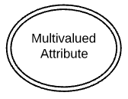
Single value attribute
Simple and composite Attribute
The attribute that cannot be further sub-divided into smaller parts and represents the basic
meaning is called simple attribute. e.g.’age’.’Roll no’ etc.
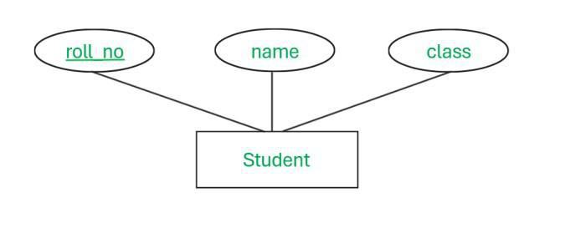
Composite attributes are attributes that can be further divided into smaller units and each
individual unit contains a specific meaning. .e.g. The ‘NAME ‘attribute of an employee entity
can be subdivided into ‘First name’, middle name’, ‘last name’.
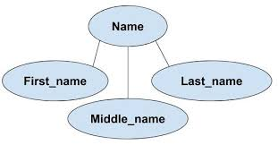
Stored Attribute- The stored attribute are those attribute which doesn’t require any type of further update since they are stored in the database.
Example: DOB(Date of birth) is the stored attribute.
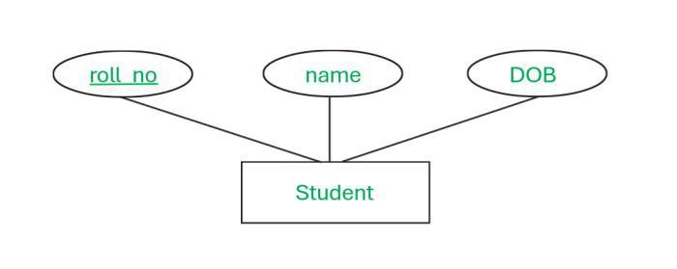
Derived Attribute
An attribute that can be derived from other attributes is derived attributes. And it is represented by dotted oval shape.
Example: Total and average marks of a student, age of an employee that is derived from date of birth.
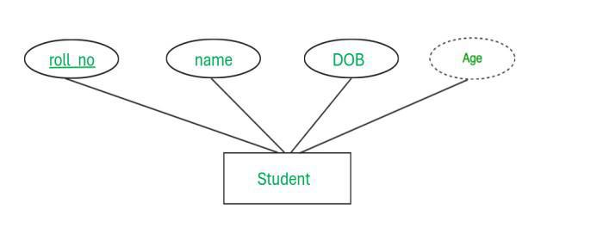

Complex Attribute
Those attributes, which can be formed by the nesting of composite and multi-valued attributes, are called “Complex Attributes“. These attributes are rarely used in DBMS.
Example: Address because address contain composite value like street, city, state, PIN code and also multivalued because one people has more than one house address.
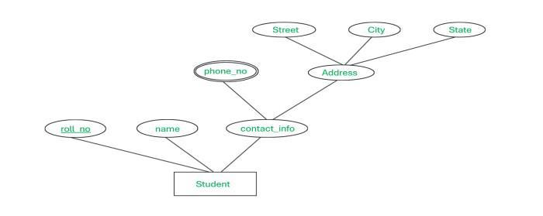
Null Attribute
This attribute can take NULL value when entity does not have value for i
* Advantages of an ER-Model
1. Simplicity and Clarity
One of the most significant advantages of ER Models is their simplicity. They provide a clear and straightforward way to visualize data relationships. This simplicity makes it easier for stakeholders, including non-technical team members, to understand the structure of the database without needing in-depth technical knowledge. This clarity is particularly beneficial during the initial stages of database design, where a comprehensive understanding of data requirements is crucial for successful implementation.
2. Effective Communication
ER Models serve as an excellent communication tool between database designers, developers, and end-users. The visual nature of ER diagrams facilitates better discussion and feedback, ensuring that all parties have a shared understanding of the database structure. This shared understanding helps prevent miscommunication and ensures that the final database design meets the needs and expectations of all stakeholders, enhancing collaboration and reducing the risk of costly redesigns later in the development process.
3. Enhanced Documentation
An ER Model provides comprehensive documentation of the database structure. This documentation is invaluable for future maintenance and updates, as it offers a detailed map of how data is organized and interconnected. Having detailed documentation simplifies onboarding for new team members and ensures continuity, as the ER Model can serve as a reference guide for understanding the database’s architecture and its underlying logic.
4. Supports Database Design
ER Models are crucial during the database design phase. They help in organizing data requirements systematically and identifying the relationships among different data entities. This structured approach ensures that the database is well-designed from the outset, reducing the likelihood of issues down the line. By visually mapping out data interactions, ER Models assist in identifying potential problems early, such as redundant data or unclear relationships, thus facilitating a more efficient and effective design process.
5. Facilitates Data Integrity
By clearly defining relationships and constraints between data entities, ER Models help maintain data integrity. For instance, primary and foreign keys can be visually mapped, ensuring that referential integrity is upheld within the database. This particular mapping of data relationships ensures that data remains accurate and consistent, preventing irregularities such as orphan records or duplicate entries, which can compromise the quality and reliability of the database.
6. Adaptability
ER Models are adaptable and can be easily modified to reflect changes in the system’s requirements. This flexibility is essential in dynamic business environments where data requirements may evolve over time. Being able to update the ER Model to incorporate new data entities, relationships, or attributes without disrupting the existing structure ensures that the database can grow and adapt alongside the organization’s needs.
7. Promotes Efficient Querying
A well-structured ER Model can lead to efficient database querying. By understanding the relationships and dependencies between entities, developers can write optimized queries that enhance performance and speed up data retrieval. This efficiency is particularly important for applications that require quick and reliable access to large volumes of data, as optimized queries can significantly reduce load times and improve the overall user experience.
Disadvantages of an ER-Model
1. Complexity in Large Systems
While ER Models are straightforward for smaller systems, they can become exceedingly complex as the system grows. Large databases with numerous entities and relationships can result in convoluted diagrams that are difficult to read and manage. This complexity can obscure the overall understanding of the database structure, making it challenging to maintain and troubleshoot, especially as more entities and relationships are added over time.
2. Time-Consuming Development
Creating an ER Model can be time-consuming, particularly for large and complex databases. The process requires meticulous planning and detailed analysis to ensure accuracy, which can delay the development timeline. The initial investment in time and resources can be substantial, and if not managed properly, it can lead to project delays and increased costs, especially when dealing with intricate data requirements.
3. Limited to Logical Design
ER Models primarily focus on the logical design of a database and do not directly address physical database design. Additional steps are necessary to translate the ER Model into a physical schema, which can introduce potential discrepancies if not handled carefully. The transition from logical to physical design requires careful planning and attention to detail to ensure that the final implementation accurately reflects the intended design and performance requirements.
4. Hardness in Design
Once an ER Model is established, making significant changes can be challenging. Any alteration in the database requirements might necessitate a substantial redesign of the ER Model, which can be both time-consuming and resource-intensive. This rigidity can be a drawback in fast-paced environments where requirements frequently change, as it can limit the ability to quickly adapt and implement new features or changes.
5. Potential for Oversimplification
In striving for simplicity, ER Models can sometimes oversimplify real-world scenarios. Complex relationships and constraints might not be fully captured, leading to a less accurate representation of the actual data requirements. This oversimplification can result in a database design that does not fully meet the needs of the application, requiring additional adjustments and refinements during development.
6. Not Always Intuitive for Newcomers
For individuals new to database design, ER Models might not be immediately intuitive. Understanding the notation and conventions used in ER diagrams requires some level of training and experience. Without proper guidance, newcomers may struggle to interpret the diagrams correctly, which can lead to misunderstandings and errors in the database design process.
7. Scalability Issues
Scalability can be a concern with ER Models. As the amount of data and the number of entities increase, maintaining and updating the ER Model can become unwieldy, potentially hindering the database’s performance and manageability. Ensuring that the ER Model remains scalable requires careful planning and ongoing evaluation to manage the complexity and ensure that the database continues to perform efficiently as it grows.
What is Mapping Cardinalities?
In a Database Management System (DBMS), mapping cardinalities explains how entities (tables) in a database schema relate to one another. They provide the number of instances of one entity that can be linked to the number of instances of another entity via a certain kind of relationship, such as many-to-many, one-to-one, one-to-many, or one-to-many. Designing exact links between tables, preserving data integrity, and simulating actual business operations in a database all depend on the mapping of cardinalities. They are a cornerstone of database design’s entity-relationship paradigm.
Whenever an attribute of one entity type refers to another entity type, then some relationship exists between them

Mapping Cardinality/Cardinality Ratio
Mapping cardinality is the maximum number of relationship instances in which an entity can participate.
Example:
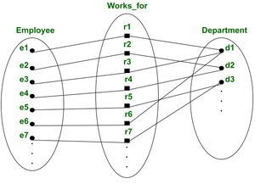
Entity type employee is related to department entity type by works_for relationship
Mathematically, here (e1, e2,e3…) are instances of an entity set Employee and (d1,d2, d3 ….) are the instances of entity type department and (r1, r2, r3 …) are relationship instances of relationship type.
Each instance ri(where i = 1,2,3,….) in R, is an association of entities, and the association includes exactly one entity from each participating entity type. Each such relationship instance, ri represents that the entities participating in ri are related in some way by any constraint/condition provided by the user to a designer.
- In works_for binary relationship type Department: Employee is of cardinality (N:1), this means each department can be related to any number of employees but an employee can be related to (works for) only one department.
- The possible cardinality ratios of binary relationship types are (1:1, 1:N, N:1, N:M).
Participation or existence constraint:
It represents the minimum number of relationship instances that each entity can participate in and it is also called the minimum cardinality constraint. There are two types of participation constraints, which are total and partial.

1. One to one relationship (1:1)
It is represented using an arrow(⇢,⇠)(There can be many notations possible for the ER diagram).
Example:
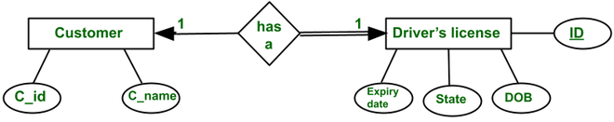
One to One relationship
In this ER diagram, both entities customer and driving license having an arrow which means the entity Customer is participating in the relation “has a” in a one-to-one fashion. It could be read as ‘Each customer has exactly one driving license and every driving license is associated with exactly one customer.
The set-theoretic perspective of the ER diagram is
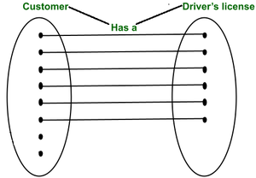
ER diagram
There may be customers who do not have a credit card, but every credit card is associated with exactly one customer. Therefore, the entity customer has total participation in a relation.

2. One to many relationship (1:M)
Example:
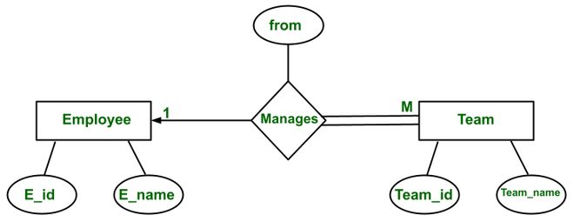
one to many relationship
This relationship is one to many because “There are some employees who manage more than one team while there is only one manager to manage a team”.
The set-theoretic perspective of the ER diagram is:
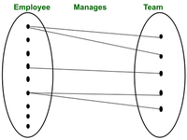
ER diagram
3. Many to one relationship (M:1)
Example:
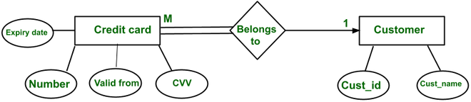
Many to one realtionship
It is related to a one-to-many relationship but the difference is due to perspective.
Any number of credit cards can belong to a customer and there might be some customers who do not have any credit card, but every credit card in a system has to be associated with an employee (i.e. total participation). While a single credit card can not belong to multiple customers.
The set-theoretic perspective of the ER diagram is:
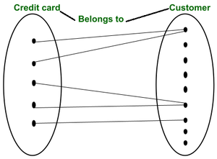
ER diagram
4. Many to many relationship (M:N)
Example:
A customer can buy any number of products and a product can be bought by many customers.
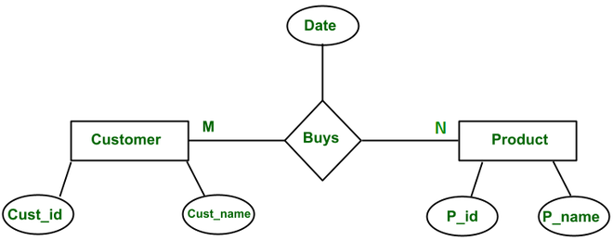
Many to many Relationship
The set-theoretic perspective of the ER diagram is:
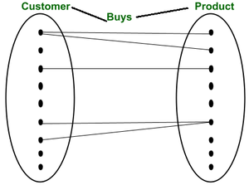
ER diagram
Any of the four cardinalities of a binary relationship can have both sides partial, both total, and one partial, and one total participation, depending on the constraints specified by user requirements.

